EXPERIMENT 7
SERIAL COMMUNICATION USING ARDUINO WITH PROTEUS
AIM: To write an Embedded C program for serial communication using Arduino Uno and Proteus.
SOFTWARE REQUIRED: Proteus 8 software; Arduino IDE software
ALGORITHM
- Initialize serial communication at 9600 baud.
- Start the counter at zero.
- Print the text and current number to the serial monitor.
- Wait 500 ms, increment the number, and repeat.
PROGRAM
void setup()
{
Serial.begin(9600); // send and receive at 9600 baud
}
int number = 0;
void loop()
{
Serial.print("Number is ");
Serial.println(number); // print the number
delay(500); // delay half second between numbers
number++; // to the next number
}
OUTPUT IMAGE
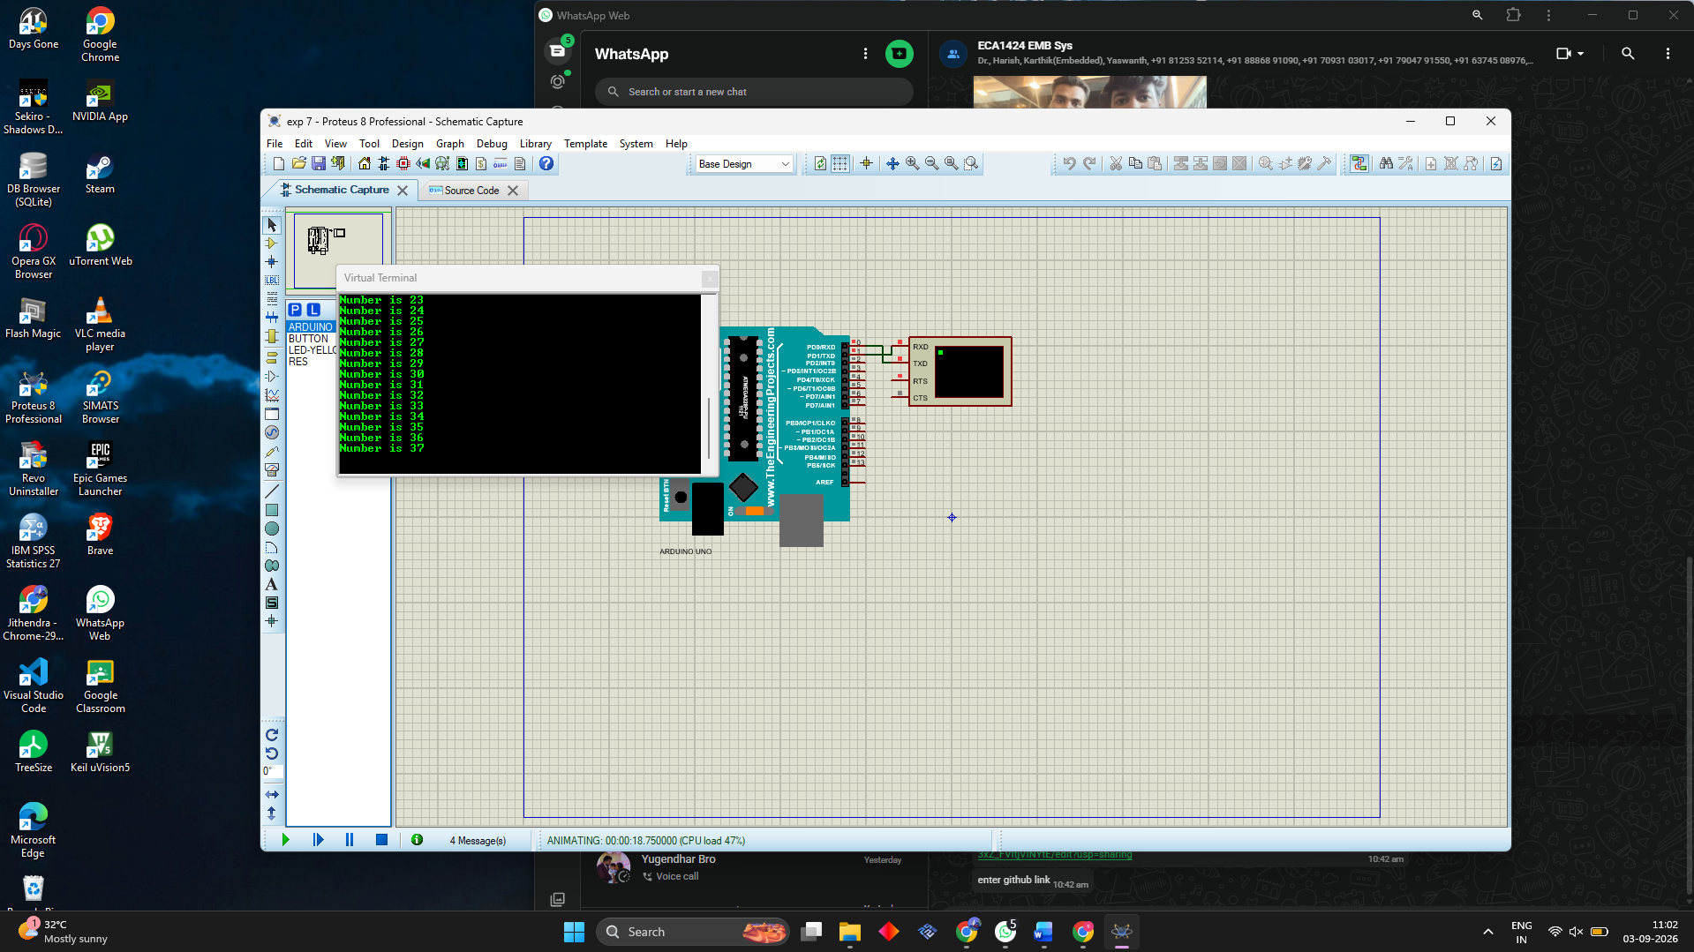
RESULT
Thus the program has been successfully verified and executed.

